Assignment 2 (for Chapter 2)
2.3 Forbes magazine publishes the Forbes Platinum 400 –a list of the “Best Big Companies in America” as selected by the magazine’s writers and editors. Table above gives the best companies in the retailing industry as given in this list on the Forbes website on March 16, 2005.(Data in the last page).
a. Construct a stem-and-leaf display of the profit margin percentages for the best performing retailers as given in Table. Use the whole numbers from 1 to 24 as the stems. Then describe the distribution of profit margins.
Stem-and-Leaf Display of Profit Margin n = 35
Leaf Unit = 0.10
 | Frequency |  | Stem
 | 2 |  | 1| | 1 8
 | 2 |  | 2| | 2 9
 | 6 |  | 3| | 1 2 3 6 6 9
 | 4 |  | 4| | 0 4 7 9
 | 12 |  | 5| | 0 0 0 2 3 4 8 9 9 9 9 9
 | 3 |  | 6| | 1 8 9
 | 1 |  | 7| | 0
 | 1 |  | 8| | 6
 | 1 |  | 9| | 2
 | 1 |  | 10| | 9
 | 1 |  | 11| | 2
 |  |  | 12|
 |  |  | 13|
 |  |  | 14|
 |  |  | 15|
 |  |  | 16|
 |  |  | 17|
 |  |  | 18|
 |  |  | 19|
 |  |  | 20|
 |  |  | 21|
 |  |  | 22|
 |  |  | 23|
 | 1 |  | 24| | 0

Distribution is skewed to the right.
b. Construct a stem-and leaf display of the return on capital percentages for the retailers in Table. Use the whole numbers from 0 to 33 as the stems. Then describe the distribution of the return.
Stem-and-Leaf of Display on Capital n = 35
Leaf Unit = 0.10
 | Frequency |  | Stem
 | 1 |  | 0| | 0
 |  |  | 1|
 |  |  | 2|
 |  |  | 3|
 | 1 |  | 4| | 0
 |  |  | 5|
 |  |  | 6|
 |  |  | 7|
 | 2 |  | 8| | 3 6
 | 1 |  | 9| | 2
 |  |  | 10|
 | 4 |  | 11| | 0 2 5 6
 | 3 |  | 12| | 6 7 8
 | 1 |  | 13| | 1
 | 3 |  | 14| | 4 7 7
 | 3 |  | 15| | 2 4 9
 | 1 |  | 16| | 5
 | 2 |  | 17| | 0 6
 | 1 |  | 18| | 3
 | 3 |  | 19| | 2 7 8
 | 3 |  | 20| | 3 6 8
 | 2 |  | 21| | 1 7
 | 1 |  | 22| | 8
 |  |  | 23|
 |  |  | 24|
 | 2 |  | 25| | 1 7
 |  |  | 26|
 |  |  | 27|
 |  |  | 28|
 |  |  | 29|
 |  |  | 30|
 |  |  | 31|
 |  |  | 32|
 | 1 |  | 33| | 4
Distribution is quite variable, but symmetric with both high and low outliers.

c. Compare the distributions of the profit margins and return on capital percentages.
Profit margins are skewed to the right and less spread out when compared to Return on Capital.
d. Organize data of the profit margin percentages into a frequency distribution.
k=6
Class length=(24-1.1)/6=3.81 round up to 3.9
To form the first class, start with the smallest value 1.1.
Up limit of the first chass is 1.1+3.9-0.1=4.9
Class Frequency Boundaries
1.1 to 4.9 14 1.05, 4.95
5.0 to 8.8 17 4.95, 8.85
8.9 to 12.7 3 8.85, 12.75
12.8 to 16.6 0 12.75, 16.65
16.7 to 20.5 0 16.65, 20.55
20.6 to 24.4 1 20.55, 24.45

e. Construct a histogram of the profit margin percentages.
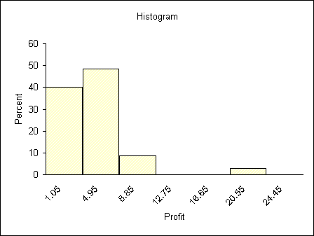

2.15 Calculate the mean, median and mode of each of the following populations of numbers:
a. 9, 8, 10, 10, 12, 6, 11, 10, 12, 8
b. 110, 120, 70, 90, 90, 100, 80, 130, 140
Solution
N MEAN MEDIAN MODE
a 10 9.600 10.000 10.00
b 9 103.33 100.00 90.00

2.18 The BANK CUSTOMER WAITING TIME CASE (WaitTime Data)(Data in the last page).
The following table presents the waiting times for teller service during peak business hours of 100 randomly selected bank customers.
- Does the sample mean 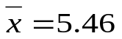provide evidence that the mean of the population of all possible customer waiting times during peak business hours is less than six minutes (as is desired by the bank manager)? Explain your answer.

Yes, because and the sample mean is the point estimate of the population mean.

- Use the stem-and-leaf display in Figure below to verify that the median of the waiting times is 5.25. How do the mean and median compare? What does the stem-and-leaf display tell you about why they compare this way?

Stem and Leaf plot for | WaitTime
stem unit = | 1 |  | leaf unit = |  | 0.1
Frequency | Stem | Leaf
2 | 0 | 4 8
6 | 1 | 1 3 4 6 8 8
9 | 2 | 0 2 3 4 5 7 8 9 9
11 | 3 | 1 2 4 5 6 7 7 8 8 9 9
17 | 4 | 0 0 1 2 3 3 3 4 4 5 5 5 6 7 7 8 9
15 | 5 | 0 1 1 2 2 3 4 4 5 6 6 7 8 8 8
13 | 6 | 1 1 2 3 3 3 4 5 5 6 7 7 8
10 | 7 | 0 2 2 3 4 4 5 7 8 9
7 | 8 | 0 1 3 4 6 6 7
6 | 9 | 1 2 3 5 8 9
3 | 10 | 2 7 9
1 | 11 | 6
100

Solution

The mean is slightly larger than the median. The stem-and-leaf display is somewhat skewed to the right.

2.36 In order to control costs, a company wishes to study the amount of money its sales force spends entertaining clients. The following is a random sample of six entertaining expenses (dinner costs for four people) from expense reports submitted by members of the sales force
$157 $132 $109 $145 $125 $139
- Calculate , 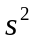, and s for the expense data. In addition, show that the two different formulas for calculating give the same result.
Solution
= 276.7
Also

- Assuming that the distribution of entertainment expenses is approximately normally distributed, calculate estimates of tolerance intervals containing 68.26 percent, 95.44 percent, and 99.73 percent of all entertainment expenses by the sales force.
Solution

- If a member of the sales force submits an entertaining expense (dinner cost for four) of $190, should this expense be considered unusually high ( and possibly worthy of investigation by the company)? Explain your answer.
Solution
Yes, because $190 is not within the 99.73% interval.

- Compute the z-score for each of the six entertainment expenses.
Solution
z₁₅₇= 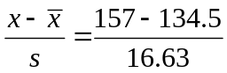 = 1.353
z₁₃₂ = –0.150
z₁₀₉ = –1.533
z₁₄₅ = 0.631
z₁₂₅ = –0.571
z₁₃₉ = 0.271

2.38 THE BANK CUSTOMER WAITING TIME CASE (waiting time case) (Data in the last page).
The mean and the standard deviation of the sample of 100 bank customer waiting times are =5.46 and s=2.475.
- Construct the histogram for WaitingTime data. What do the histogram say about whether the Empirical Rule should be used to describe the bank customer waiting times?
Solution
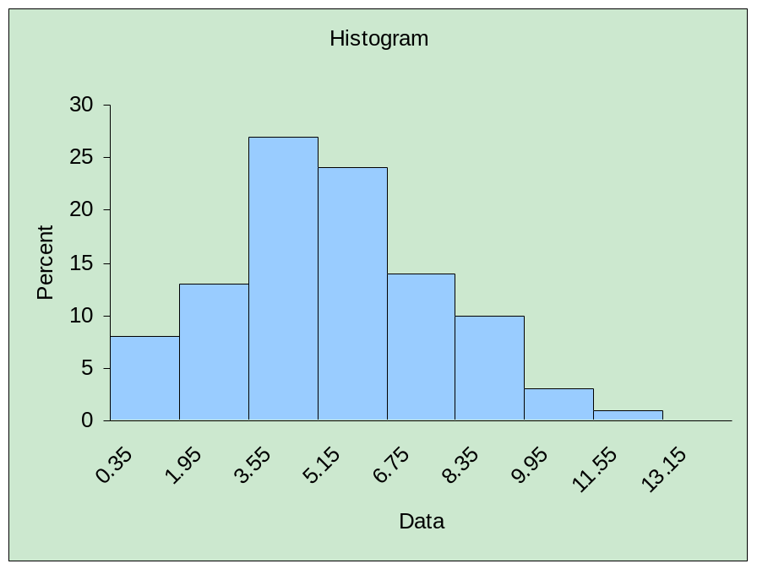
It is somewhat reasonable.
The Empirical Rule should be used. Because the Rule not only holds for normally distributed populations, but also approximately holds for populations having mound-shaped distributions that are not very skewed to the right or left.

- Use the Empirical Rule to calculate estimates of tolerance intervals containing 68.26 percent, 95.44 percent and 99.73 percent of all possible bank customer waiting times.
Solution

- Does the estimate of a tolerance interval containing 68.26 percent of all waiting times provide evidence that at least two-thirds of all customers will have to wait less than eight minutes for service? Explain your answer.
Solution
Yes, because the upper limit of the 68.26% interval is less than 8 minutes.

- How do the percentages of the 100 waiting times that actually fall into the intervals [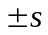],[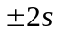], and [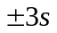] compare to those given by the Empirical Rule? Do these comparisons indicate that the statistical inference you made in parts b and c are reasonably valid?
Solution
66% fall into 96% fall into , 100% fall into .
Yes, they are reasonably valid.

2.46 Considering ForbesPlat Data concerning the best performing retailers from the Forbes Platinum 400 as listed on the Forbes magazine website on March 16, 2005. (Data in the last page).
a. Construct a box-and-whiskers display for the return on capital percentages of the best performing retailers.
Solution
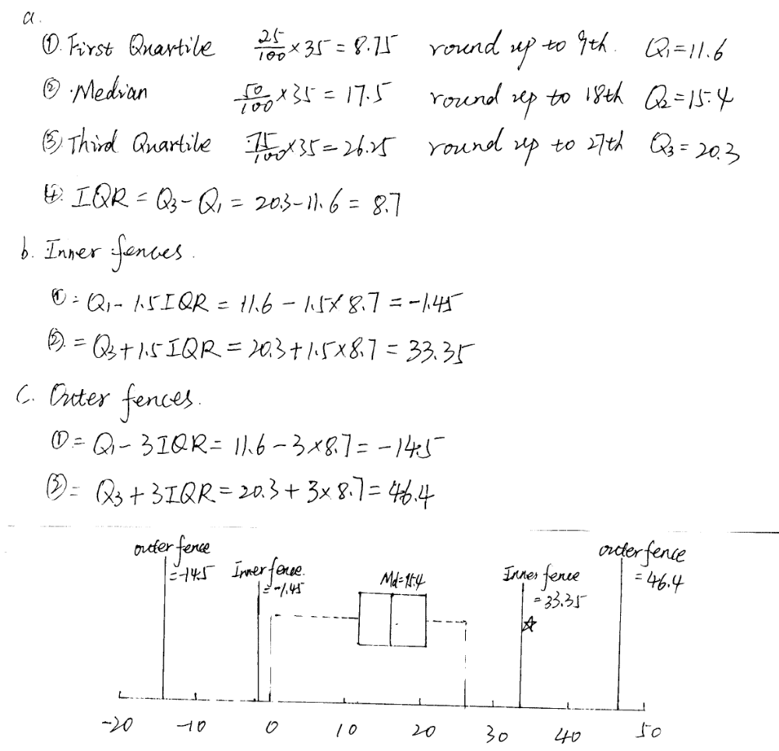

b. Using the box-and-whiskers display, describe the distribution of the return on capital percentages with respect to central tendency, skewness and outliers.
Solution
According the box-and-whiskers display, the return percentages have a
median of 15.40. The distribution is reasonably symmetric with one
mild outlier.

2.54 On March 11, 2005, the Gallup Organization released the results of a CNN/USA Today/Gallup national poll regarding Internet usage in the United States. Each of 1,008 randomly selected adults was asked to respond to the following question:

“As you may know, there are Web sites known as ‘blogs’ or ‘Web logs’, where people sometimes post their thoughts. How familiar are you with ‘blogs’-very familiar, somewhat familiar, not too familiar, or not at all familiar?”

The poll’s results were as follows: Very familiar (7%); Somewhat familiar (19%); Not too familiar (18%); Not at all familiar (56%). Use these data to construct a bar chart and a pie chart.
Solution
Bar chart
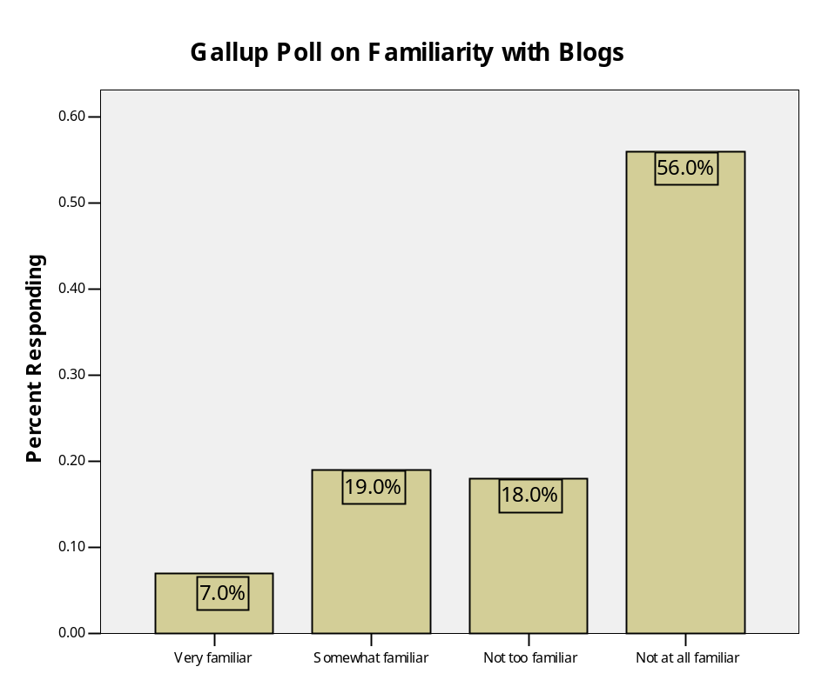

Pie chart
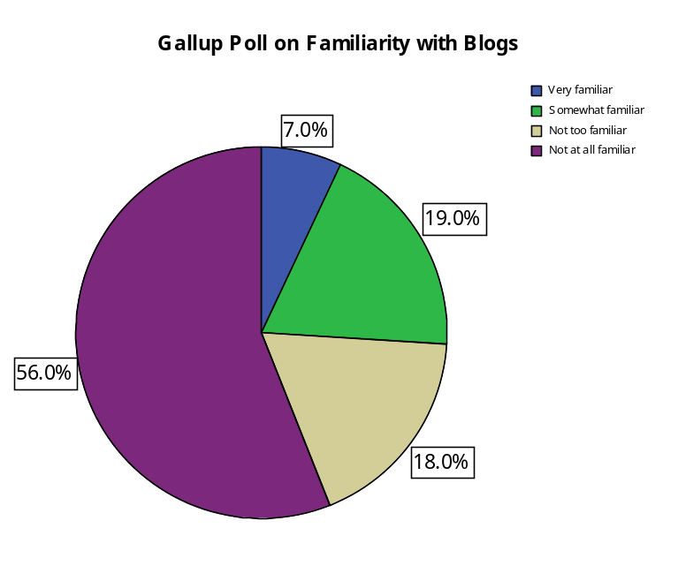

Waiting Times (in minutes)
1.6 6.6 5.6 5.1 3.9 4.6 6.5 6.4 8.6 4.2 5.8 3.4 9.3
7.4 1.8 6.2 5.4 4.9 5.4 0.8 2.5 8.3 6.1 6.3
6.8 9.8 2.9 10.9 4.7 3.9 3.2 6.5 2.3 8.7 4.7
3.6 2.7 3.7 0.4 10.2 2.8 11.6 4.3 3.1 5.8 5.6
4.4 4.5 6.7 8.1 4.3 2.2 5.8 8.6 2 8 9.5
1.3 4.8 9.9 7.9 1.1 7.2 2.9 9.1 7.7 4 1.4
7.8 5.2 8.4 6.3 4.4 5.2 7.4 6.1 3.8 10.7 7.5
7 5.3 4.5 4.5 1.8 3.7 4 5.7 2.4 9.2 5
7.2 7.3 4.1 6.7 3.5 6.3 4.3 3.8 5.1 5.5

The Forbes platinum list: Best-performing retailers as listed at Forbes.com on March 16, 2005

Company | Profit | Return on Capital (%)
 | Margin (%) | Last 12 Months
Abercrombie & Fitch | 10.9 | 25.7
Advance Auto Parts | 5.0 | 17.0
Amer Eagle Outfitters | 6.1 | 14.7
AnnTaylor Stores | 5.9 | 11.6
Bed Bath & Beyond | 9.2 | 22.8
Best Buy | 3.3 | 21.7
CDW | 4.0 | 20.6
Charming Shoppes | 3.1 | 8.3
Claire's Stores | 11.2 | 20.3
Costco Wholesale | 1.8 | 0.0
CVS | 3.2 | 11.2
Dollar General | 4.4 | 18.3
Ebay | 24.0 | 13.1
Electronics Boutique | 2.9 | 19.2
Family Dollar Stores | 5.0 | 19.7
Foot Locker | 5.3 | 12.8
Fred's | 2.2 | 9.2
Guitar Center | 3.9 | 15.9
Home Depot | 6.9 | 19.8
Kohl's | 5.9 | 11.5
Lowe's Cos | 5.9 | 14.7
Michaels Stores | 5.9 | 14.4
Neiman Marcus Group | 5.8 | 12.7
O'Reilly Automotive | 7.0 | 12.6
Pacific Sunwear | 8.6 | 25.1
Petsmart | 5.0 | 15.4
Regis | 5.4 | 11.0
SCP Pool | 5.2 | 20.8
Staples | 4.7 | 15.2
Target | 6.8 | 8.6
TJX Cos | 4.9 | 33.4
Tractor Supply | 3.6 | 16.5
United Auto Group | 1.1 | 4.0
Walgreen | 3.6 | 17.6
Williams-Sonoma | 5.9 | 21.1

